Social and Professional Issues

Tutorial 1 Social and Professional Issues

Tutorial 1



Law

-The misuse of the content. For example, spreading misinformation or using for cybercrime

-Due to the free flow of information and the exchange of content it could cause infringement of copyright.

-Need laws to combat cyber crime (e.g. selling drugs or weapons via dark web) E.g. Computer Misuse Act (CMA), Computer fraud and abuse act (CFAA)

Markets

-good thing to business man / business world, got more platforms, e.g. emerge of e-marketplace in internet, Lazada, Shopee

-Using the Internet for the online business. For example, online shopping

-The growth of online mobile services

-The arrival of the online platform lowers the costs of doing business.

Architecture

-Improve hardware to provide more reliable and smoother access to the Internet. Eg. more variety of internet service/architecture & subscription plan available in the market, wired internet connection, wireless/wi-fi internet connection, wider broadband internet subscription plan (fixed monthly data plan, unlimited data usage plan)

-software change. E.g. More and more new software launch in the market with more new enhance features/functions. E.g. Windows…..offline software/system → web-based system/software ----> mobile apps

-hardware change. E.g. more lighter and more easier to carry,

Social Norms

-People use the Internet to interact with each other, to find information or to obtain information. E.g. Lesser F2F interaction

Scenario 1: Student assigned to do assignment / homework

Without Internet(before): go library/ find newspaper to get information

With Internet (after): search from internet to get more information

|  |
| --- |
|  |



Yes, It is necessary for computing professionals to know laws related to IT because as the rise of computer technology, Computers Help the computing professionals to learn, develop, share, communicate and find entertainment and always act within the legal boundary.

However, it is also possible for computers to be used to aid illegal activities. An understanding of computer-related laws is needed to make sure we stay on the right side of the law.

Additionally, the internet may allow people to commit crimes remotely, such as stealing other people's personal data or blackmailing someone, thus laws are required to help us to deter such activities whether it is ethical or not.

|  |
| --- |
|  |



- Declined job categories: Manufacturing factory workers

-Nowadays a lot of factories already replace manpower using machines that are controlled by computers. This is because by using machines there will be better productivity compared to manpower. Machine automation helps to reduce cost and produce the products which are in good quality even though the quantity is big.

- Increased job categories: IT trainers, IT related position (e.g. programmer, web developer, mobile apps developer, database administrator, network administrator…)

-It is because a lot of work is already done by using machines or systems which are related to IT. Therefore, IT trainers play an important role to train the staff to use the system correctly thus they can carry out their work efficiently.

|  |
| --- |
|  |



Pros of BYOD

* Save Cost

- Company will no need to spend more money to buy new laptops for every employee because the employees have their own laptops.

* Enhanced Productivity

- With BYOD, technicians can use the equipment they already know, and only need less training. They will know how to make full use of equipment functions, which will improve staff productivity and maximize business revenue.

-Improved work flexibility

- With BYOD, the employees will have the flexibility to work at any time and anywhere, and it shall not be restricted by a normal working hour of 9-5 jobs. Besides that, it also can make employees be able to work if they were unable to go to the specific working place.

Cons (Disadvantages) of BYOD

* Need to buy Own laptop

- Companies will not need to spend more money to buy new laptops for every employee because the employees have their own laptops. Add on additional cost burden to worker as they need to spend money to equip themselves with their own pieces of equipment/gadget. What if the device/gadget lost/damaged along the work, who should be here to bear for those loss/can the worker claim for compensation??

* Risk of losing personal data (from worker point of view)

- On employees quitting or being terminated, most companies will require the employees to either hand over the equipment or allow the equipment.to be completely reset, including all personal data to prevent the company data from being leaked from that employee. Example, they access Facebook after work.

- Security and data breach concern/worry (from company point of view)

- Company might worry that those staff who are resigned, retire from work, or being fired to retained a copy of company private and confidential company data/resources inside their own device and then re-sell it to the third party/outsiders.

- Workload increase-Due to flexibility of time and can work at any place, employee who are BYOD might have over workload problem.

|  |
| --- |
|  |

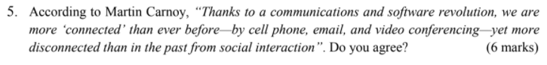

Yes, besides that, due to the communication and software revolution, it is easier to connect with friends/classmates/colleagues,

E.g. friend context - Call to friend, see and chat with friend using video conferencing, share resources using email

Exchange resource/share data/idea among each other using email, social media (e.g. WhatsApp, Instagram, Facebook, Twitter, WeChat)

-In term of study/student life, (e.g. google classroom, meet, using internet resources to complete assignment/task assigned…)

-in term of work/business world, (e.g. Use zoom to have virtual meeting to report work progress, to make business decision, observe/monitor work progress, etc.)

|  |
| --- |
|  |

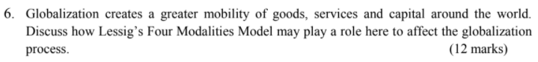

Law: New laws are created and existing laws are enforced under the globalization process. For example, laws that cover privacy or data protection are set up and enforced to protect privacy right

Social norm: Globalization makes changes in way of communication between people, for example people can use video calls/social media/email to interact with each other even when they live far away from each other.

Markets: Foreign exchange allows more products and services to be available, while also lowering costs, because of specialization. It increases competition (make difficult for small business to survive/fight against big brand player), increase company competitive advantages, and also helps establish global economies.

Architecture: With the evolving internet, the globalization process can be sped up and information can be updated in the next second. For example, hardwares are becoming smaller and more powerful which can help in improving the architecture of technologies as well as reducing cost. Software launch new version with more and more new features to support…..

|  |
| --- |
|  |

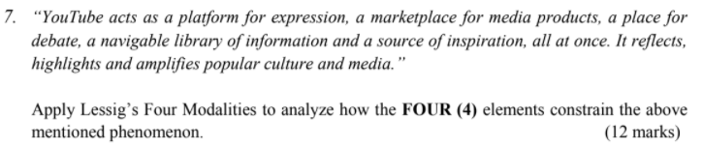

Law

- Most of the common people are ignoring the rules and regulation or the terms and conditions before they sign up for YouTube but The Terms take effect when users subscribe to the required YouTube online service, and they rule all daily experiences of the game.

E.g. rules to ensure public won’t simply post those inappropriate content into YouTube channel else ppl can report to YouTube administrator to take action against it.

● Social norms

- More and more people now have learned and know more about the knowledge on creating and editing the videos, and this has caused people to be able to upload any type of video easily.

E.g. use YouTube to watch movie/MTV/live reality show, listen to song as part of your leisure activity…...

● Markets

- Media products of real business will face many virtual competitors because the YouTube economic scale is bigger than real business.

- business owner/merchant may place their product/service advertisement through popular YouTube channel to promote their product/service

● Architecture (environment, platform, software, hardware)

- All things become virtual, this will reduce the face-to-face interactions between each other and cannot touch to get the real feeling at the real time.

E.g. what are those available/evolution of technologies, functionality /features to support the operating of YouTube.

- choose 360, 720, HD picture quality to determines sharpness /picture/video resolution quality,

- choose of playback speed from 0.25, 0.75, 1(normal), 1.25, 1.75, 2

- emerge of third party software/technology to enable you to download YouTube video…

- enable subtitle

-function to subscribe YouTube channel so that you receive notification upon release of new video clip, etc.

|  |
| --- |
|  |



|  |
| --- |
|  |